Intelligent Video Recorder

32CH 4K Gigabit H.265+ 2HDD IVR
NL-NV32

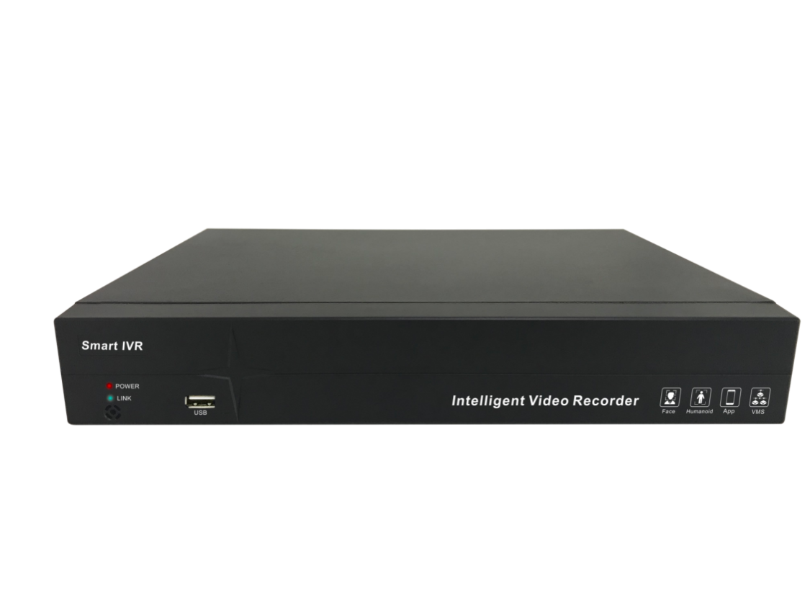

H265+ ONVIF SLINK IMS APP

Modify Light Mode Human Detect Vehicle Detect Retrograde Absent Alarm

Introduction:

H.265+ 32CH IVR, support 32CH 4K IP camera input and output, support smart analysis IPC- absent alarm, E-fence,target count, human detection,retrograde motion detection, 2 pcs HDD (max 10TB), 1CH VGA, 1 CH HDMI, support to upgrade IPC remote, modify IP camera address and light board parameters, support mobile view

Features：
● Mode 1：Support 16 Channels IPC input（8MP/D1+16 CH Preview+16 CH playback）
● Mode2：Support 25 Channels IPC input（8MP/D1+25CH Preview+9 CH playback）
● Mode 3：Support 32 Channels IPC input（8MP/D1+32CH Preview+9 CH playback）
● Support H265,H264,H265+ compression format
● Support synchronized recording,remote view,backup recording in MP4 format, mobile view
● Support VGA/HDMI
● Support preview image and playback image electronic amplification
● Support RTSP,GB28181,ONVIF protocol
● Support HTTP,RTMP
● Support alarm capture,send alarm information by email
● Support DDNS,UPNP,NTP,P2P...etc
● Support WEB, mobile view,IMS surveillance
● Support IPC smart analysis: target count, E-fence, line crossing, absent alarm, E-bike detection
● Support channel tour round grouping
●Support network inspection-network traffic monitor, ether-detect packet,network diagnosis..etc
● Support max 4CH 1080P playback
● Support HTML5 remote login operation
● Support to add IPC manually or automatically in LAN
● Support to upgrade IPC online and by memory
● Support to maintain IPC under private protocol, including restore, restart, enable or disable all network function
● Support disconnected network supplement function, optimize bandwidth incoming up to 64M

Specification：
Function
Protocol RTSP、SLINK（private protocol）、onvif、I9
Mobile View Support IOS and android mobile view
Display mode:
Mode 1:Support 16CH IPC input（8MP/D1+16CH preview+16CH playback）
Mode 2:Support 25CH IPC input（8MP/D1+25CH preview+ 9 CH playback）
Mode3:Support 32CH IPC input（8MP/D1+32CH preview+9 CH playback）
Smart Function: Target count,E-fence, line crossing,absent alarm,retrograde motion detection,human detection
Video
Normal mode 16CH IPC
Split | 1 | 4 | 6 | 8 | 9 | 16
Decode | 4K | 4*1080P | 5MP+5*D1 | 3MP+7*D1 | 9*D1 | 16*D1
Normal mode 25CH IPC
Split | 1 | 4 | 6 | 8 | 9 | 16 | 25
Decode | 4K | 4*1080P | 5MP+5*D1 | 3MP+7*D1 | 9*D1 | 16*D1 | 25*D1
Normal mode 32CH IPC
Split | 1 | 4 | 6 | 8 | 9 | 16 | 25 | 32
Decode | 4K | 4*1080P | 5MP+5*D1 | 3MP+7*D1 | 9*D1 | 16*D1 | 25*D1 | 32*D1

Incoming bandwidth 64Mbps
Compression format H.265+/H.265 /H.264
Recording resolution 4K/5MP/3MP/1080P/D1
Audio compression G.711A/U
Recording and playback
Recording mode Manual/fixed time/alarm recording
Playback ability 1CH 4K/4Ch1080P/16CH sub-code
Playback mode Regular playback, event playback,external file playback
Storage and backup
Storage Port 2pcs SATA
HDD capacity Max 10T
Storage Local HDD,network HDD IPSAN
Backup mode USB protable HDD, memory
External port
Network Port 1 pcs RJ45 1000M port
USB port 2 pcs USB2.0
General
Power DC12V3A
Power consumption ≦30W
Working temperature/humidity -10°C ~ 55°C/10﹪-90﹪
Size(mm) 326X235X52mm
Weight/pcs（Kg) Net weight: 1.7Kg; Gross Weight: 1.92Kg（ without HDD）
Package 8 pcs/CTN. 755mm×395mm×365mm; Weight: 16KG

Size
